**MDD 2**

**Dean Kopping**

**KPPDEA001**

**Overview of the solution’s architecture:**

Over the years, with the advancement of mobile applications and mobile devices, the general population has strayed away from using books and hard copy resources as their sources of information. When seeking knowledge or simply having the desire to learn a new skill, people turn to the internet and mobile applications. There are various reasons for this which include convenience, cost as well as speed.

Appendix A displays the share of users worldwide accessing the internet in the first quarter of 2022 by device. The graph indicates that 92.1% of people worldwide are accessing the internet.

In addition to the increase in access to mobile devices, there is also an incredibly large population that are studying English. Current research suggests that there are around 1.5 billion people learning English worldwide.

From this information, it has been deduced that a mobile application which serves to help people learn the English alphabet would be a useful and sought-after application. The target audience for this alphabet book application would predominantly be younger children of below the age of ten as well as perhaps people who are learning English as an additional language.

As this is a simple and easy to use application it will be most suitable for children. The application will be made up of only two activities, a home page and a page that displays information about each letter depending on which letter is desired. Due to this simple user interface, there should not be any learning process or confusion about the functionality of the application.

The alphabet book application will provide its users with a quick and convenient way to learn each letter as well as some of the letter’s characteristics and will cater to various learning styles such as visual, auditory, reading and writing through different application features.

The alphabet book application will be a native android application and will not require a server to interface with the application. The reasoning behind this decision is that native applications are typically faster and do also not require internet connection. This allows the user to use the application at any time and any place. Young children typically have shorter attention spans and therefor a slow application may cause boredom or disinterest.

**Prototype design:**

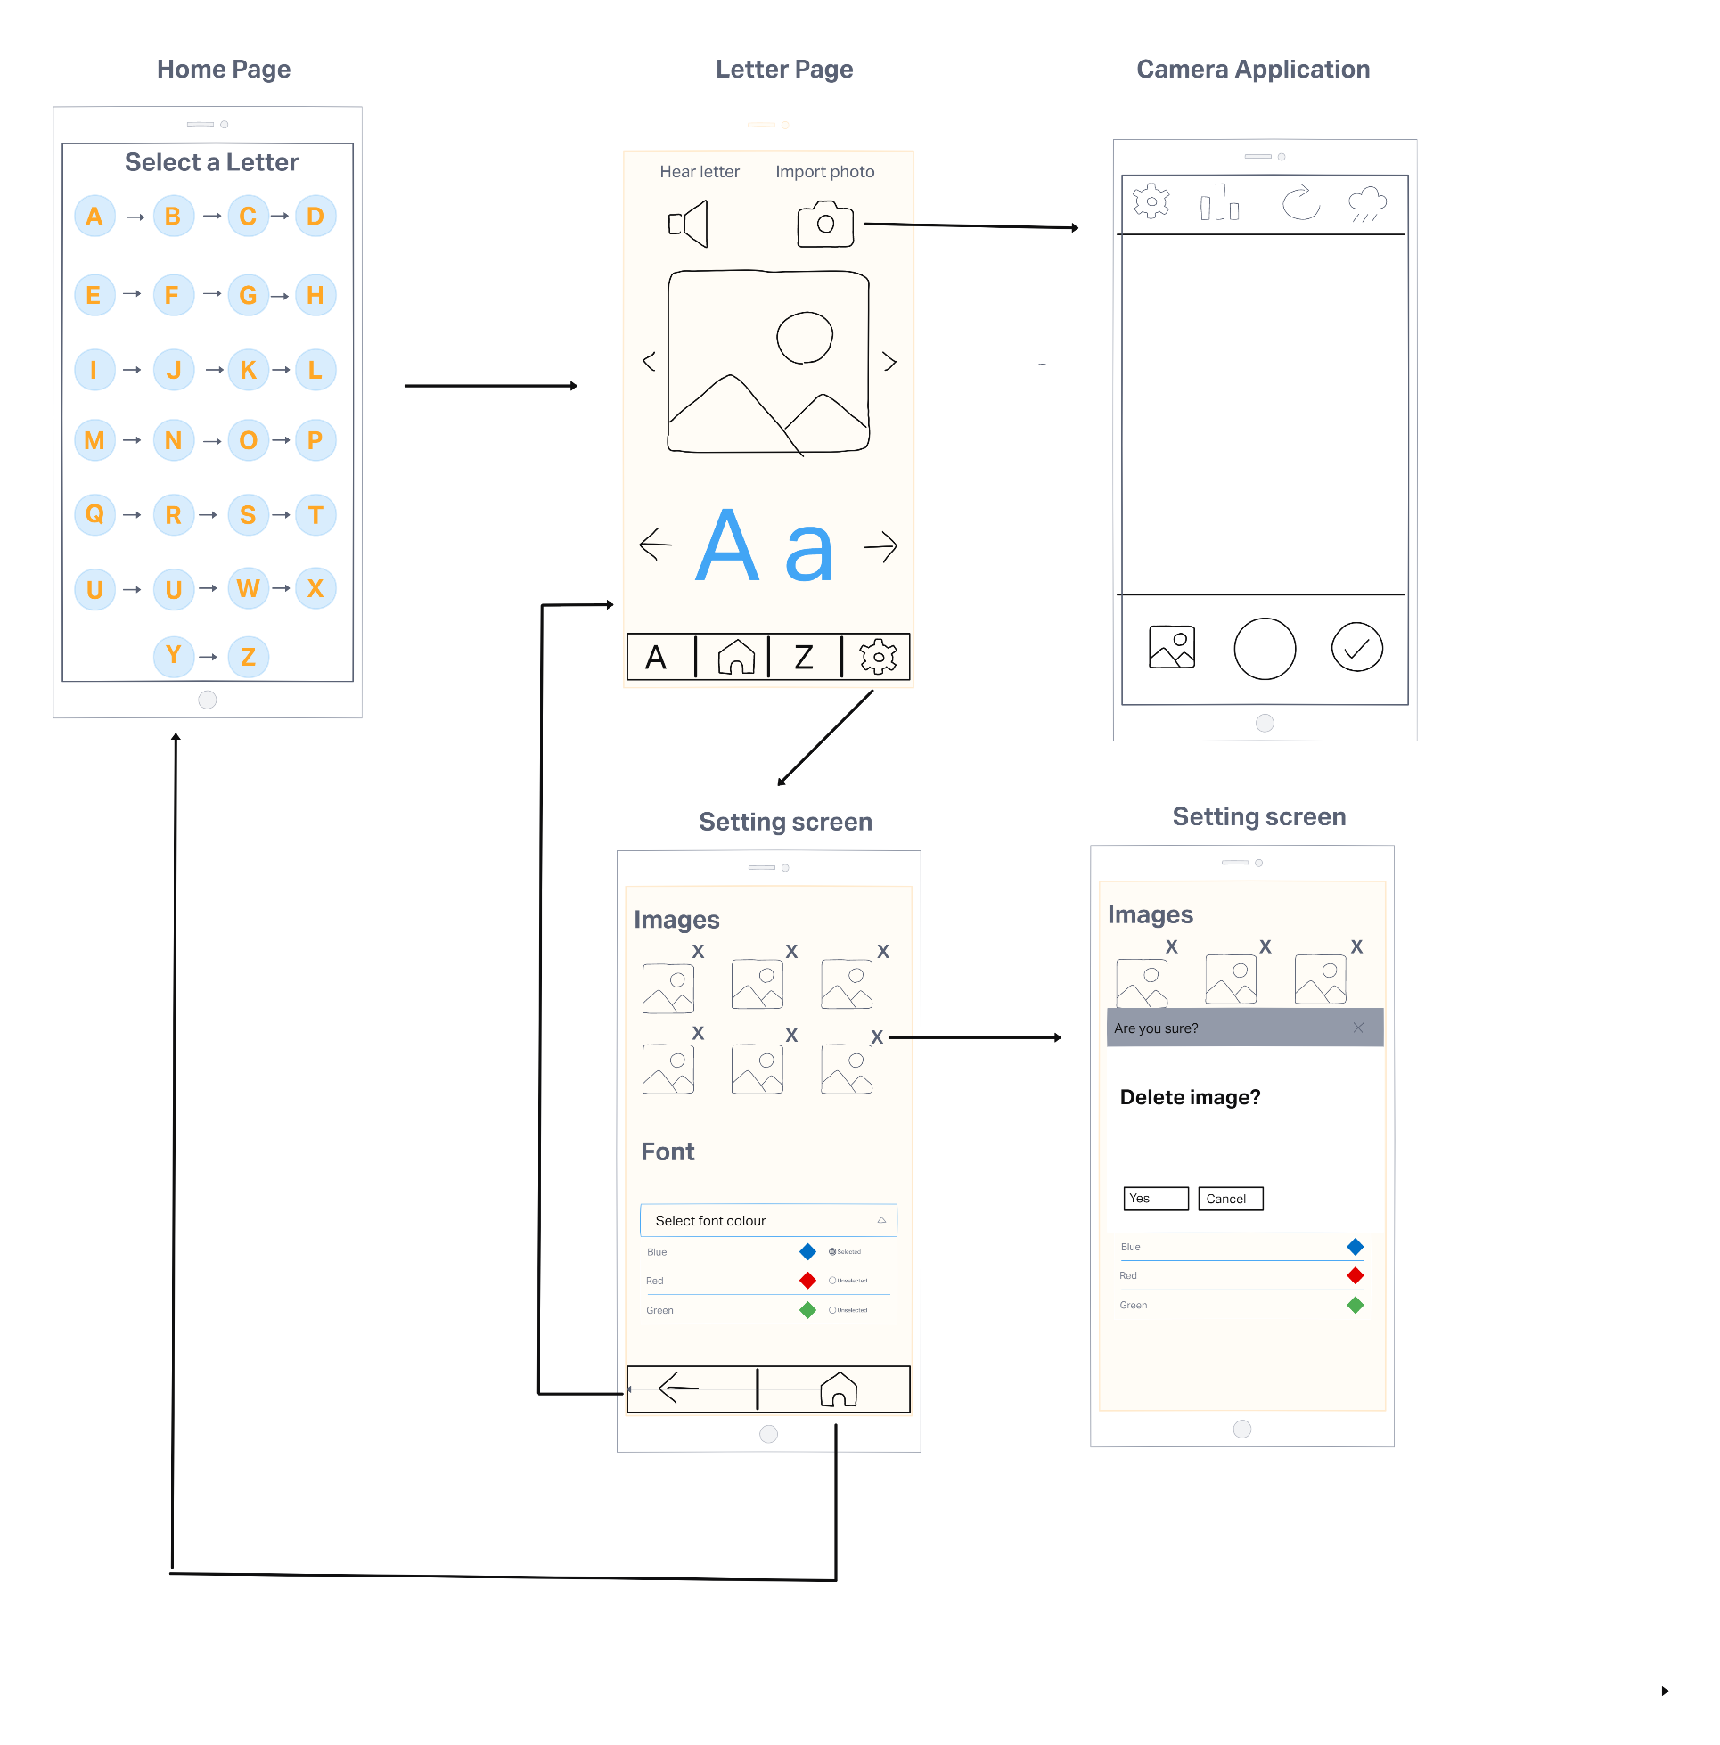

**Overview of existing alphabet book application:**

This application’s main target audience is children. Therefore, the signal to noise ratio is important. For this reason, the user interface design has been kept as simple as possible, with the home screen containing only single buttons for each letter as well as arrows to indicate the order of these letters. To maintain user interest, the letter page has been kept as uncrowded as possible.

The main focuses of the letter page are the image as well as the letter, for this reason the image has been placed in the centre of the page and the letter has been displayed largely in a bright and easy to read font.

In order to comply with Fitts law and the Pareto law, the main controls have been placed near the bottom of the screen with buttons of a reasonable size. Placing these buttons at the bottom of the screen make them easier to reach, especially for users with smaller hands such as children. These buttons include viewing the next or previous letter, jumping to A or Z, returning to the home screen or moving to the settings screen.

There are no unnecessary design aspects, and every user action will cause a change in the interface which will let the user know the action has been completed. The buttons on the home page will result in a transition to the letter page, with the relevant letter being displayed as well as a corresponding image. As expected, the A and Z buttons will transition the application to these respective letter pages while the arrows beside the letter will move to the next or previous letter page.

This design is intuitive and contains no unexpected aspects, the principal of least astonishment is met. As the main target audience of the application is children, the choice of button designs was made to be as intuitive as possible and not reliant on the user being able to read.

Aside from the reasoning for design choices mentioned above, the alphabet book application has also taken aesthetics into account. A colour scheme of blue and orange has been used as they are complementary colours, and the contrast is pleasing to the eye. In addition, round buttons are more playful and interesting then sharp angular buttons.

**Overview of New features:**

1. Users can customize the alphabet book, taking their own photos or using their own images for the different letters
2. The alphabet book includes an option for the user to hear the sound of each letter.
3. The alphabet book can store multiple images for each letter that the user can browse through.
4. The user can change the colour of the font.

The additional features which have been incorporated into the alphabet book have been added to better the application by creating a more engaging, interactive, and captivating user experience.

Being able to upload their own images helps to create a more personal and individualized experience for every user. Users can choose images that resonate with them and may give them a better understanding of each letter. This in turn will aid in the educational process as users are more likely to remember what the images if they hand selected them.

In addition, the application can store multiple images for each letter which are presented to the user in a slide show like format on each letter page, thus broadening the users understanding to more than just one image.

The option of adding multiple personal images will also extend the life expectancy of the application as users are less likely to become disinterested after seeing the same one generic image for each letter.

This feature has been implemented with the use of a button on the top right of the screen. The button has been placed in this location as while this is a useful feature, it is predicted to be used less often the other navigation type buttons. The button will take the user to the camera application on their mobile device where they can then choose to either take a photo in the moment or upload one from their gallery by pressing the button in the bottom left. The process is complete when the user presses the tick button in the bottom right corner of the camera interface.

User error is inevitable with this feature. The user may upload an image that does not correspond to the letter or simply an image they do not like. To account for this, the images can be removed by pressing on the settings button on the letter page. When deleting an image, the user will be presented with a message box to confirm their decision. Once confirmed or cancelled the message box will disappear. If confirmed, the user will know the image is deleted as it will no longer be in the displayed images on the settings screen.

Previously, the application provided only what each letter looked like and what they sound like in certain words through the use of images. This however is not sufficient for educational purposes. It is important for the alphabet book to teach the user how each letter is pronounced. For this reason, the speaker feature has been implemented. When the speaker button in the top left corner is pressed the application will play a pre-recorded audio of the letter being said. This feature also serves to make the application less on dimensional and more interactive and entertaining for younger users. Similarly, the minor customisation aspect of changing the letter colour serves the same purpose. This is done on the settings page through the use of radio buttons as only one colour may be selected at any given time. The setting for the font colour contains the word of the colour as well as a diamond to display how the colour looks.

Appendix A:

References

Beare, K., 2022. *How Many People Learn English Around the World?*. [online] ThoughtCo. Available at: <https://www.thoughtco.com/how-many-people-learn-english-globally-1210367> [Accessed 27 September 2022].

Statista. 2022. *Devices used to access the internet 2022 | Statista*. [online] Available at: <https://www.statista.com/statistics/1289755/internet-access-by-device-worldwide/> [Accessed 27 September 2022].

Studio by UXPin. 2022. *9 Principles of Mobile App Design*. [online] Available at: <https://www.uxpin.com/studio/blog/principles-mobile-app-design/> [Accessed 28 September 2022].